How to complete your Conflict of Interest/Commitment annual disclosure.

1. Log in to the UTSA Conflict of Interest Portal <https://oric.utsa.edu/coi>
2. Using your UTSA ID (abc 123) and passphrase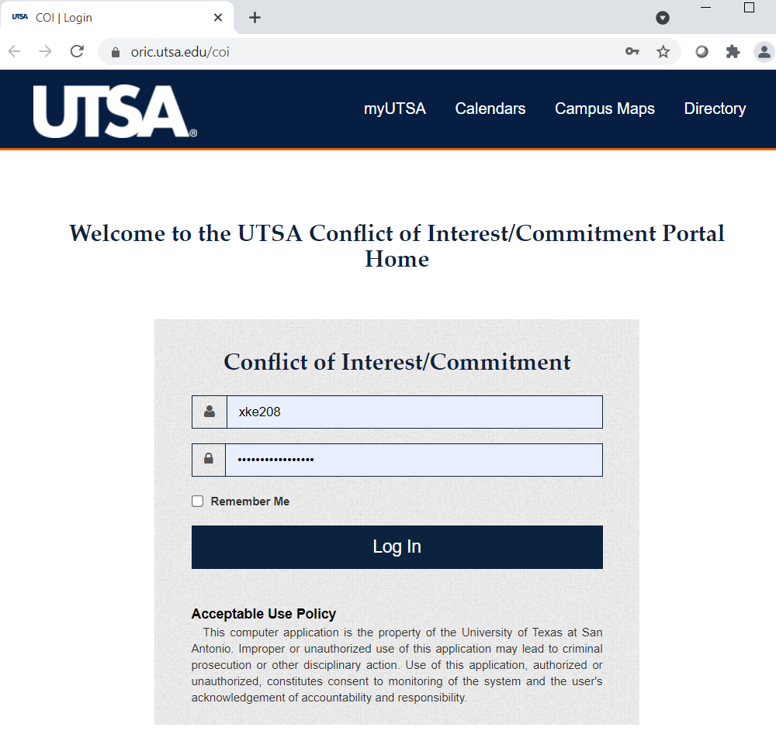
3. Choose your side **Researcher or Non-Researcher** read description below.

|  |  |
| --- | --- |
| Researcher Disclosure for (Faculty and Other Researchers) | Non-Researcher Disclosure |
|  | **Non-Researcher**  **Click here** |

**Researcher**

**Click here**

**For Researcher Disclosure STEPS** **click here**

**Non-Researcher Disclosure STEPS below**

1. Click first option as indicated below

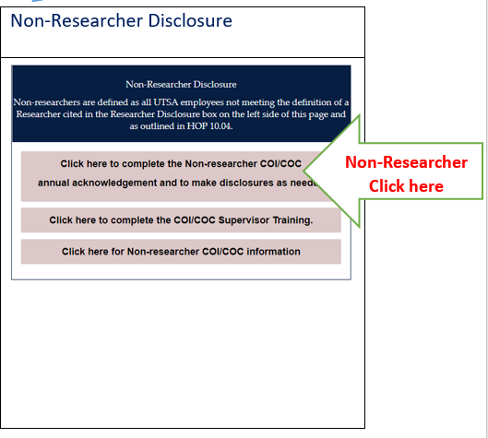

1. Confirm acknowledgment on box below.

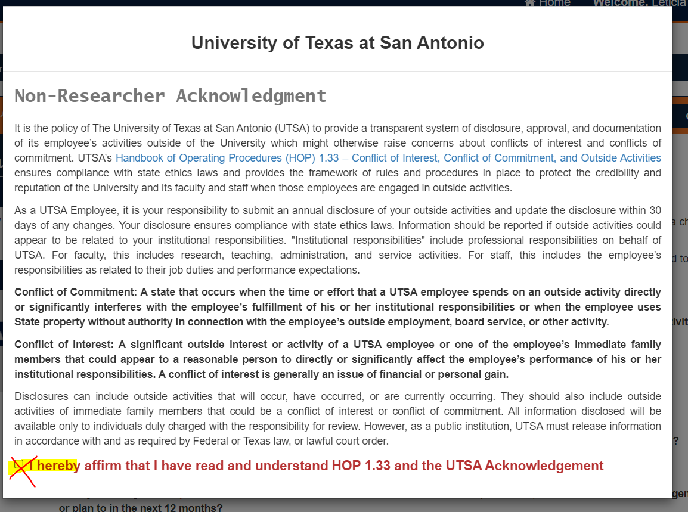

1. Answer questions “Yes” or “No” depending on your status then click “Next”

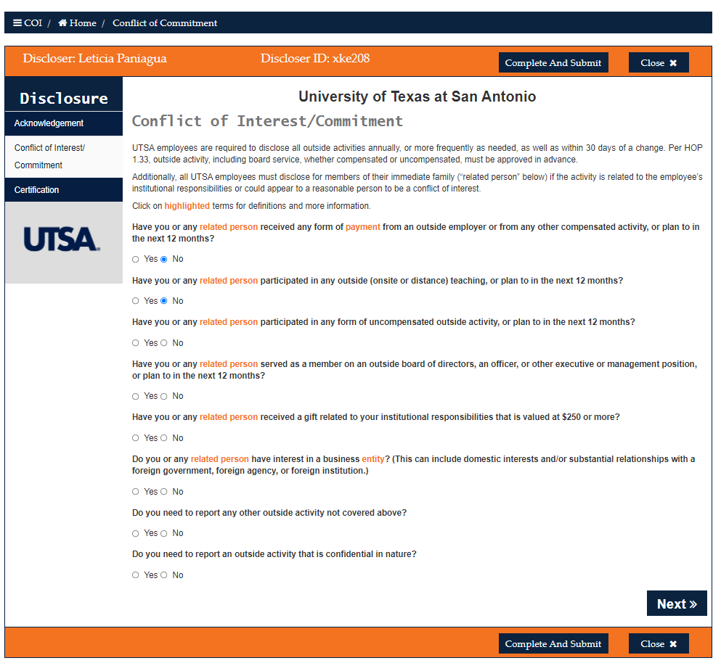

Please note if you select “Yes” on a question, you will be prompted to disclose the outside activity on a new window, add the information then click next.

Sample window, (this or similar window(s) will appear, depending on your answers).

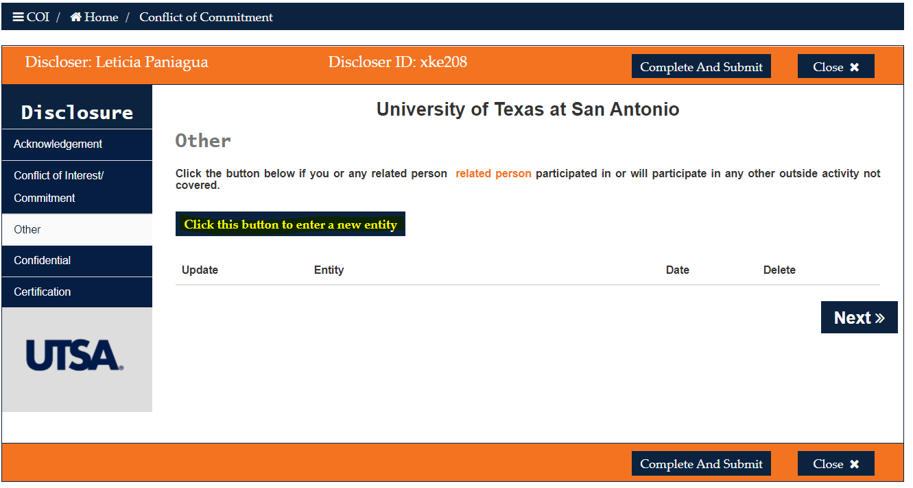

1. To certify your response click on the box, then click “Complete And Submit”

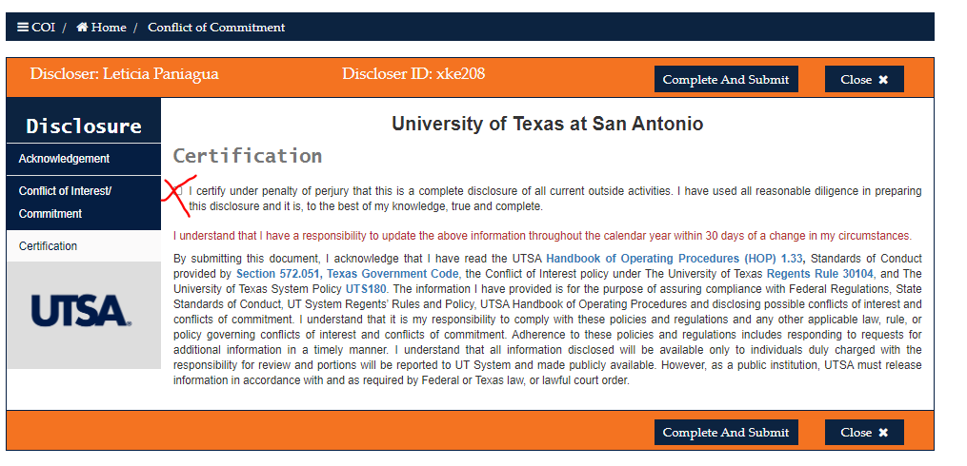

1. To confirm information click yes on yellow box.

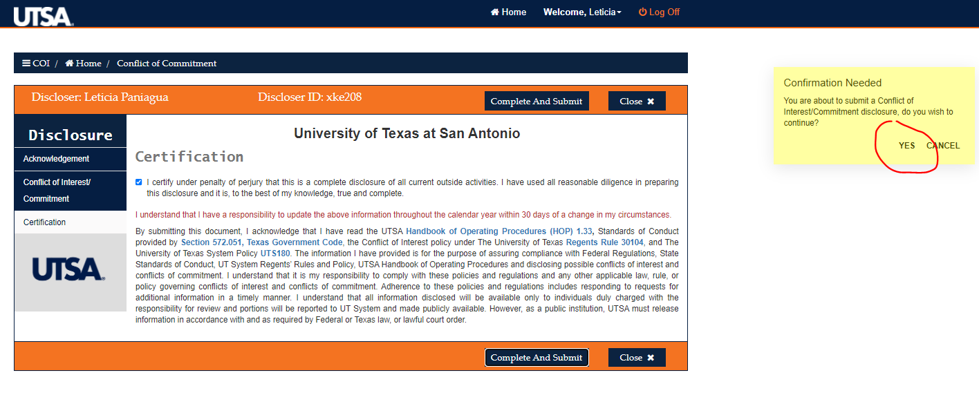

A small green window will show up once you have successfully completed your disclosure.

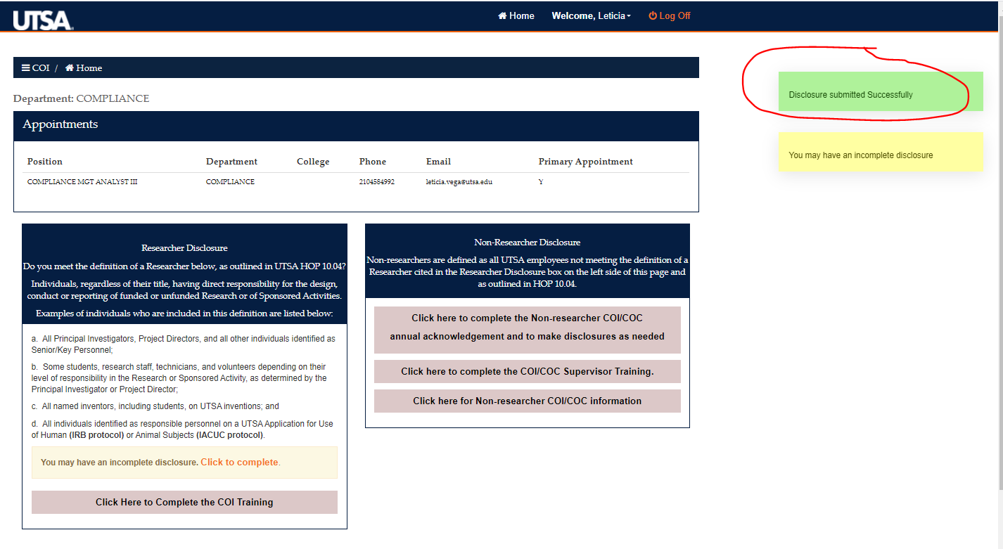

On the home page you can also see your disclosure history

Sample: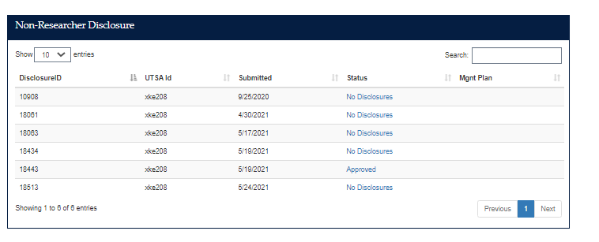

If you have any question please contact the compliance office.

Analise Lopez, COI specialist (210) 458-4158 or

Leticia Vega (210) 458-5537

**Researcher Disclosure STEPS below**

1. Click first option as indicated below

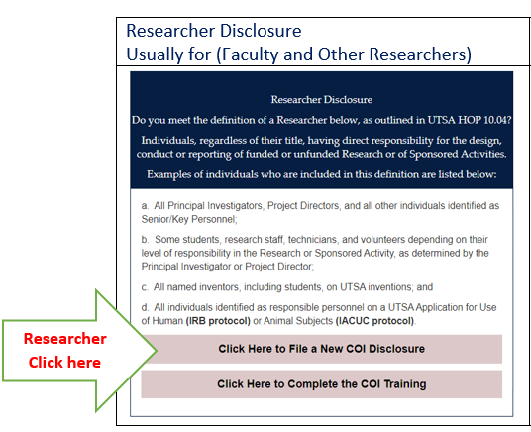

1. Confirm acknowledgment on box below.

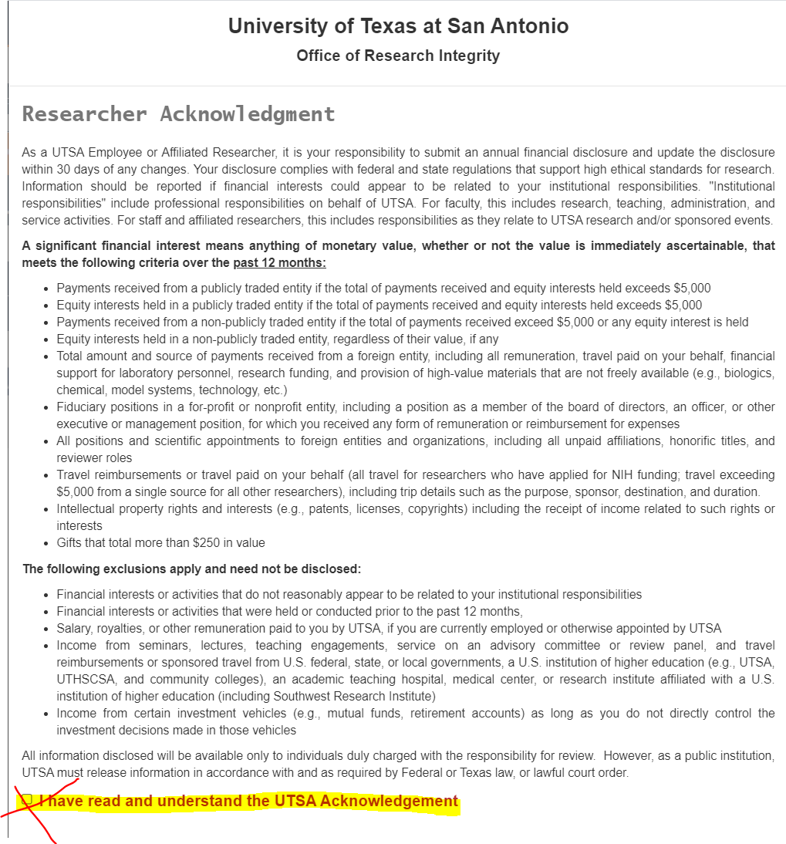

1. Answer questions “Yes” or “No” depending on your status then click “Next”

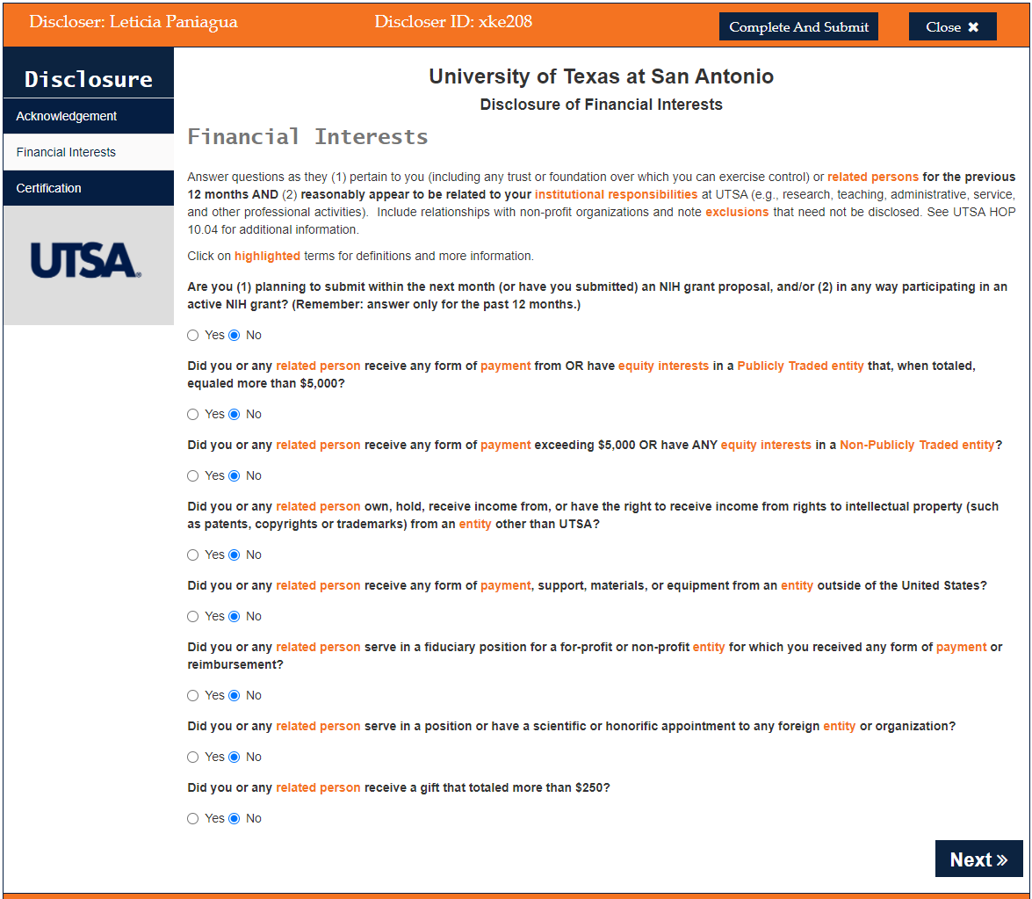

Please note if you select “Yes” on a question, you will be prompt to disclose the outside activity on a new window, add the information then click next.

Sample window, (this or similar window(s) will appear, depending on your answers).

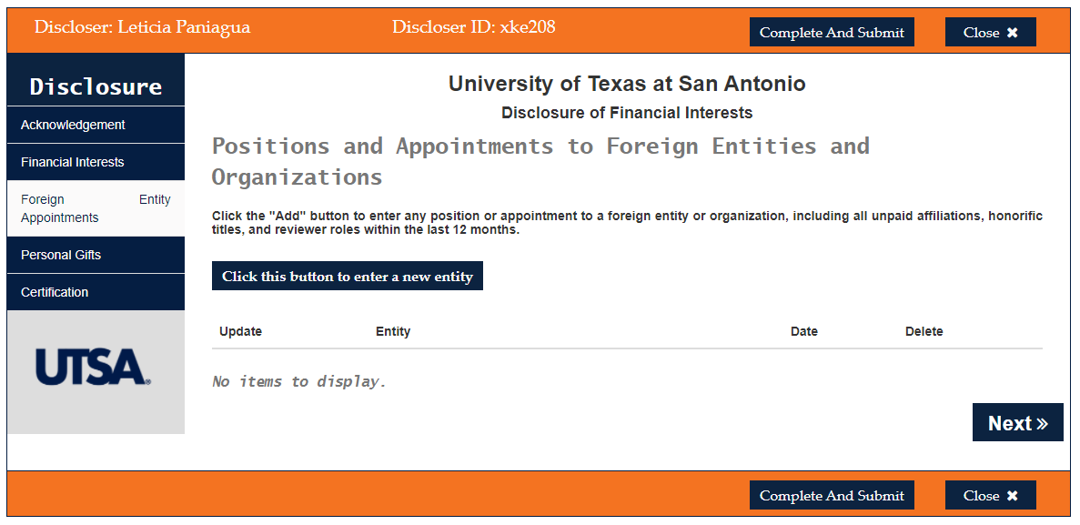

1. To certify your response click on the box, then click “Complete And Submit”

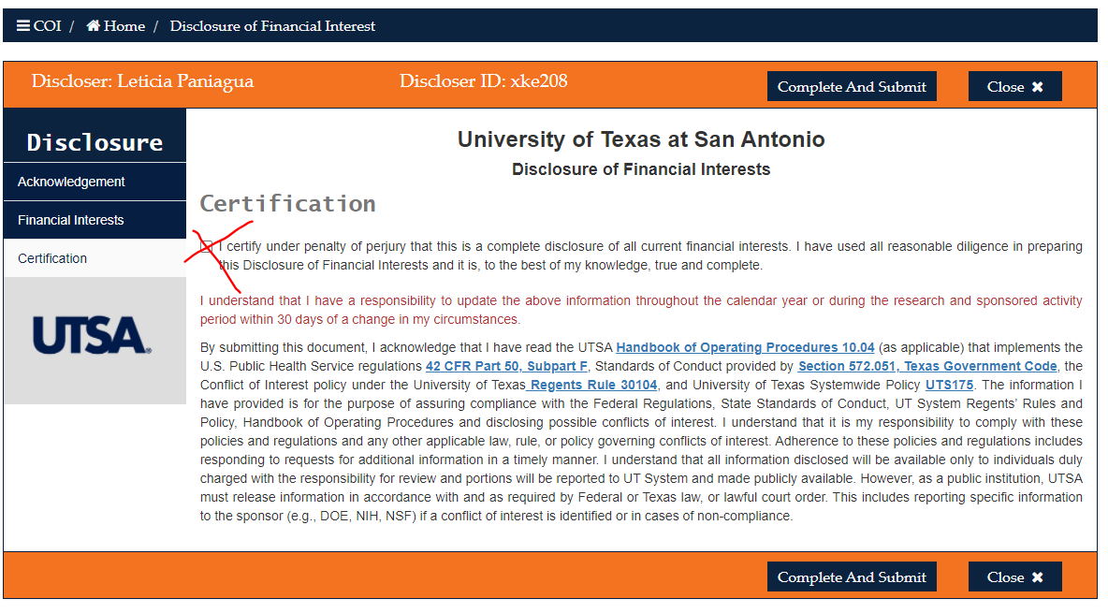

1. To confirm information click yes on yellow box.

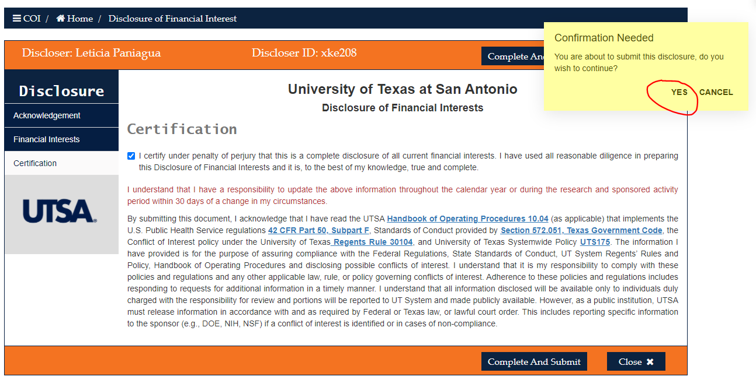

A small green window will show up once you successfully completed your disclosure.



On the home page you can also see your disclosure history

Sample:

Researchers if you have any questions related to disclosure please contact the Office of Research Integrity. Patsy Arevalo 210-458-6506 or email address: ccoi@utsa.edu

**FAQs**

1. I have completed this item, why is my status uncompleted?

* This is an annual required disclosure; ensure you have completed this item within a year.
* A history of your disclosures is available in the home page. To verify your disclosure was completed, log in to the UTSA Conflict of Interest Portal <https://oric.utsa.edu/coi> and scroll down on the home page.

1. Where do I complete the COI? Follow the steps on this guideline
2. Why do I have to do this again?  This is an annual required disclosure, all UTSA employees must submit a disclosure.
3. How a supervisor approves someone’s disclosure?

* Conflict of Interest/Commitment training is available for all supervisors, to understand their role and responsibility. Click the following link to review the training:  [https://mytraining.utsa.edu/online/course/view.php?id=162](https://nam11.safelinks.protection.outlook.com/?url=https%3A%2F%2Fmytraining.utsa.edu%2Fonline%2Fcourse%2Fview.php%3Fid%3D162&data=04%7C01%7Cleticia.vega%40utsa.edu%7C4a845af328b647f20e5308d92699e02c%7C3a228dfbc64744cb88357b20617fc906%7C0%7C0%7C637583264590635143%7CUnknown%7CTWFpbGZsb3d8eyJWIjoiMC4wLjAwMDAiLCJQIjoiV2luMzIiLCJBTiI6Ik1haWwiLCJXVCI6Mn0%3D%7C1000&sdata=xaBwMBSjU6f0F6dApYBg5WrtNuISc7i5jWfAU%2BG1Jn8%3D&reserved=0)

**Supervisor steps to approve/denied disclosure**

Supervisor will receive email notification:

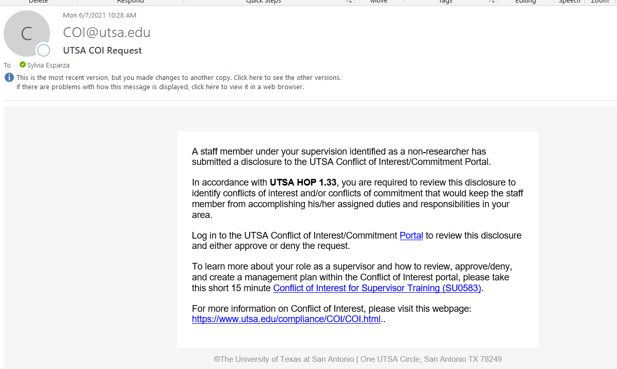

Log into COI portal using the link in the email and scroll where is says “Supervisory View”

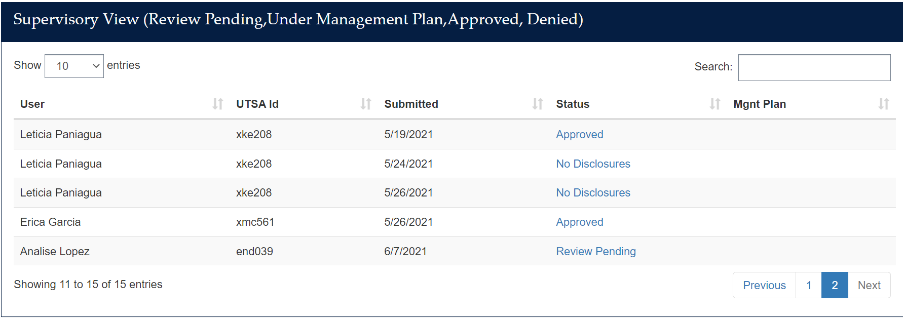

Click on the employee with “Review Pending” status.

Then click on Acknowledge/Approved, Management Plan or Denied.

To approve: Click on “Acknowledged/Approved”, then “Yes” to confirm.

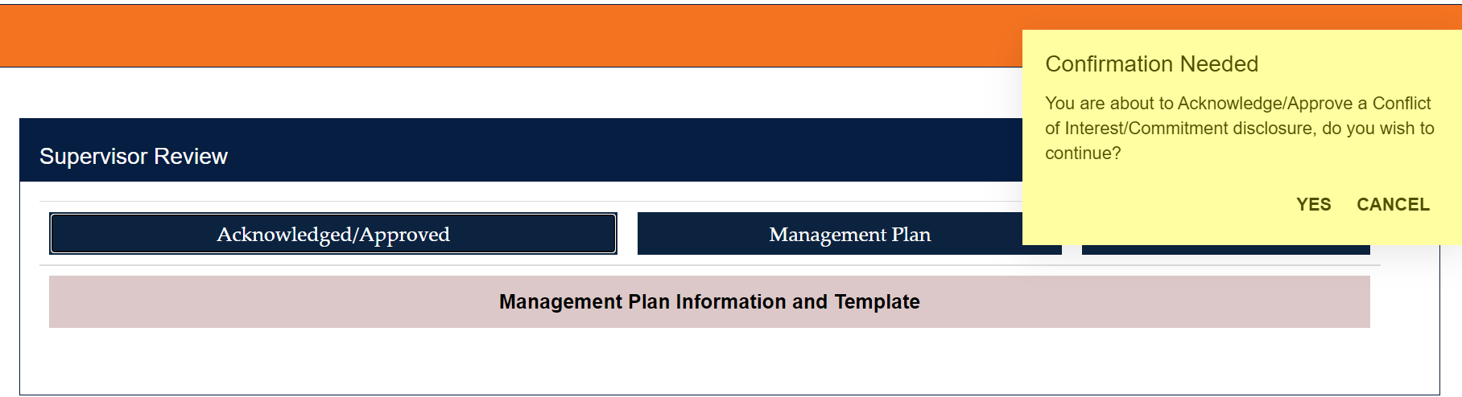

When you return to the “Supervisory View” on the HOME page, the status should be updated to “Approved”

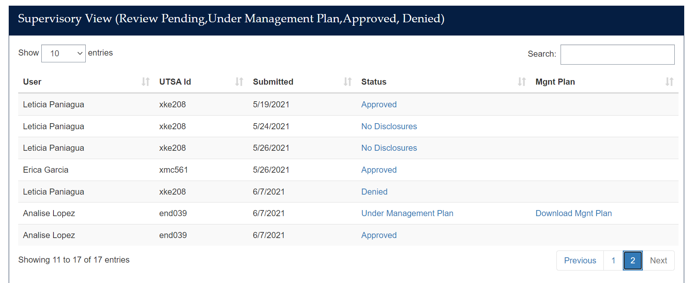

If the employee has a Management Plan, click on “Management Plan”, then “Yes” to confirm

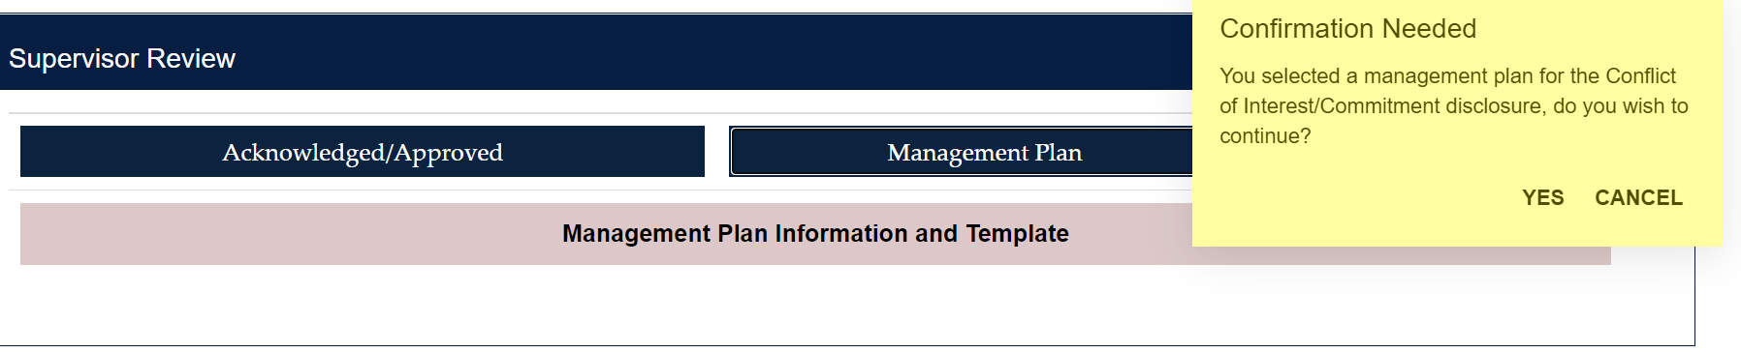

To upload the file, click on “Choose File” and select the file to be uploaded. Note: the file must be in PDF format.

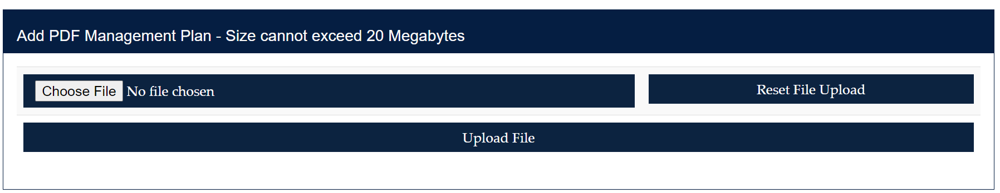

When you return to the “Supervisory View” on the HOME page, the status should be updated to “Under Management Plan”, and you will have the option to view the Management Plan by clicking on “Download Mgmt Plan”

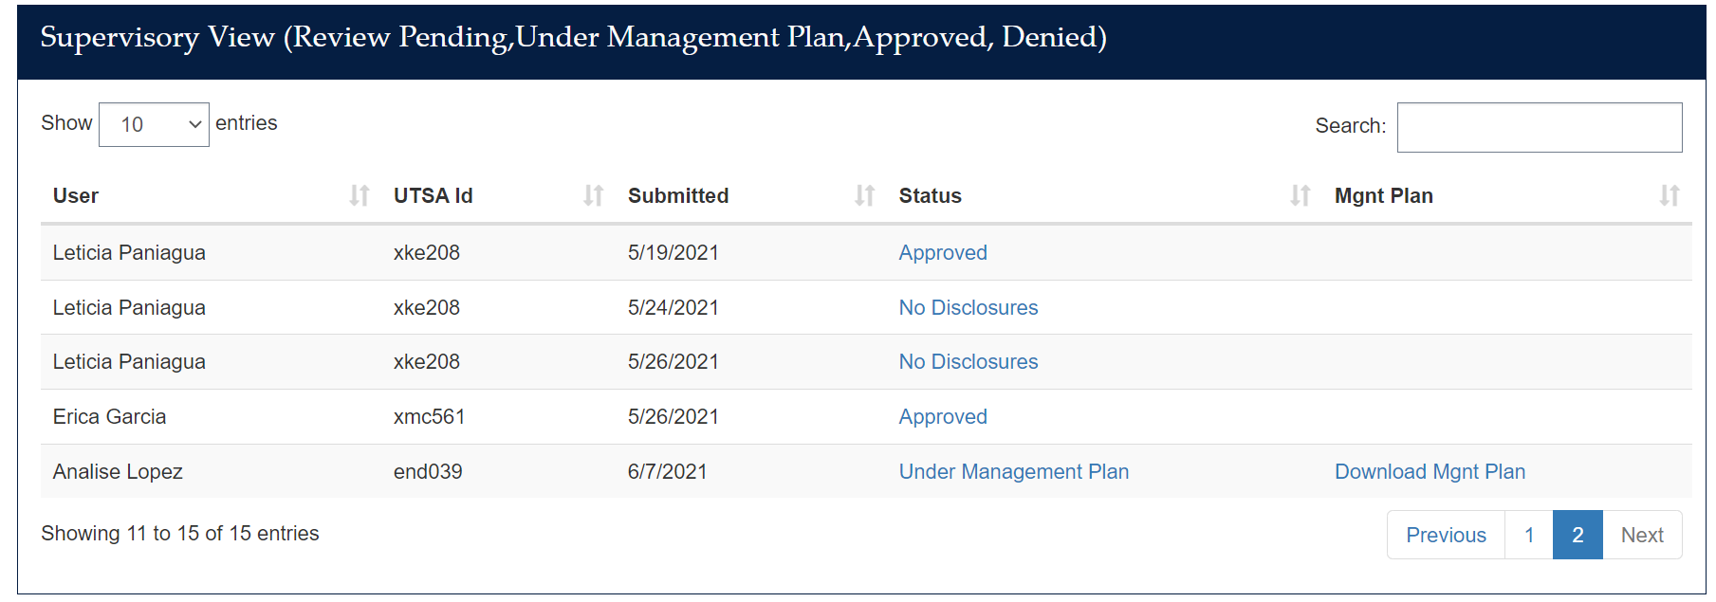

To Deny a request: Click on “Denied” then “Yes” to confirm

When you return to the “Supervisory View” on the HOME page, the status should be updated to “Denied”

